Act 1

https://youtu.be/IQA2qPsRfGM
What do you notice? What do you wonder?
How many cookies did the cookie thief eat? Estimate.
Write an estimate you know is too high. Write an estimate you know is too low.

Act 2
How many cookies were in the package?
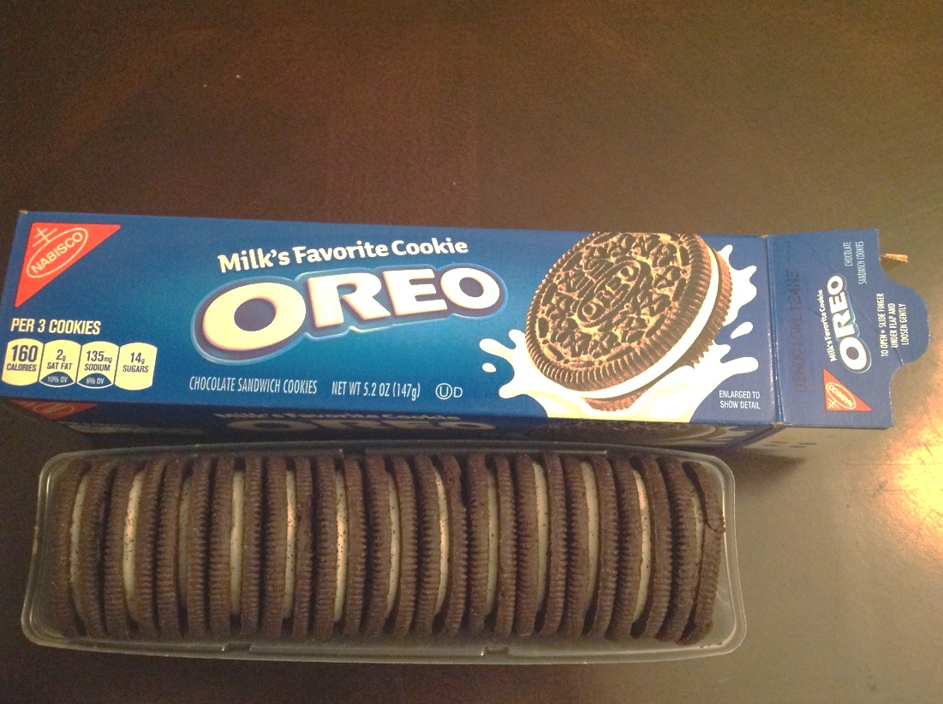

How many cookies were left?

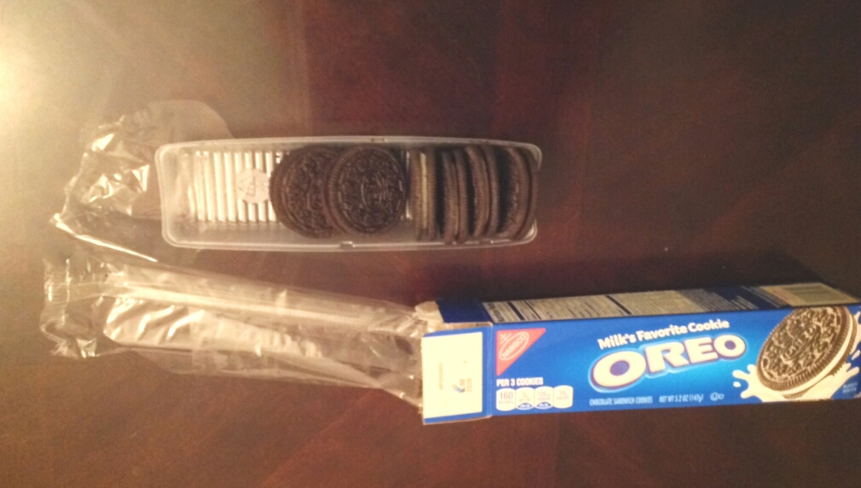

Act 3
The number of cookies the cookie thief ate.
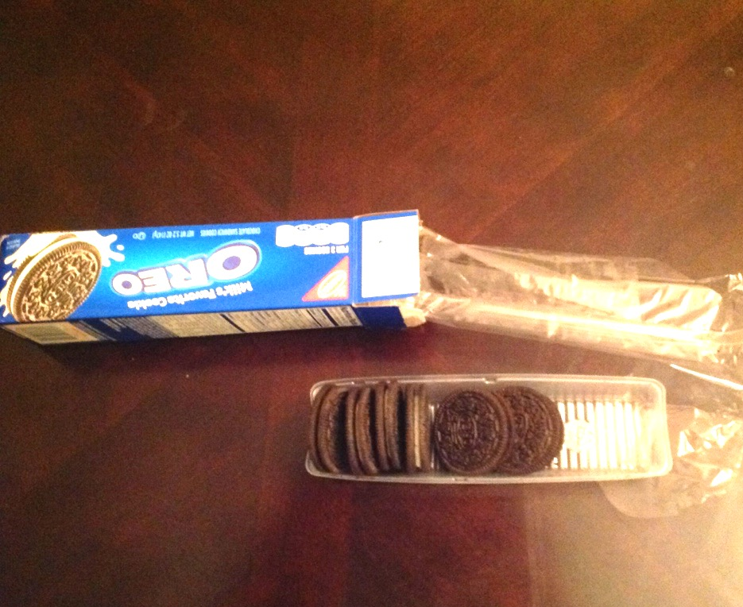
7

